SD Configuration
- Go to Start Menu > Programs > KBCI Savings and Deposit System, then select KBCI Savings and Deposit System Configuration
- Upon selecting the configuration tool will appear
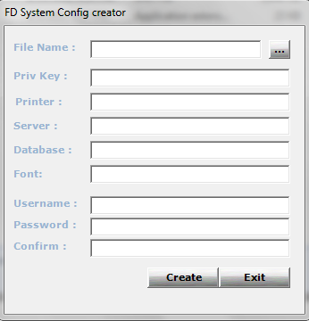

- Then using the button on the upper right part of the tool, select the configuration file that you want to configure, in this case we’ll select SDS.exe.config . Then select Open
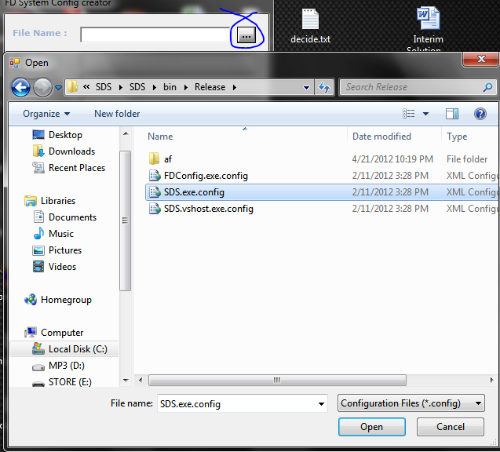

- Once the valid configuration file selected, it will display the configured settings for the system.
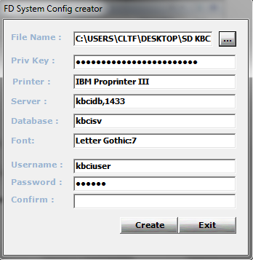

- Just make the needed changes on the configuration file, then type-in the configured password (this password is used as a credential on the Database Server) on the Confirm Field then click Create Button to apply the changes.
